**Agenda**

* Status updates
* Future experimentation design (rohith?)
* Undergraduate research day info and timeline
* 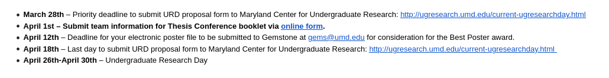
* Abstract proposal:

“Additive manufacturing (AM) enables the construction of near-arbitrary structures with the help of computational tool-path planning and print material properties. We explore an application of the technology to targeted repairs, such as mending holes, cracks, or general voids, by using a conformal tool-path planning algorithm, combining the precision of AM with surface adhesion. We further analyze the results of our repairs in contrast to alternative methods and demonstrate the usefulness of AM repairs.”